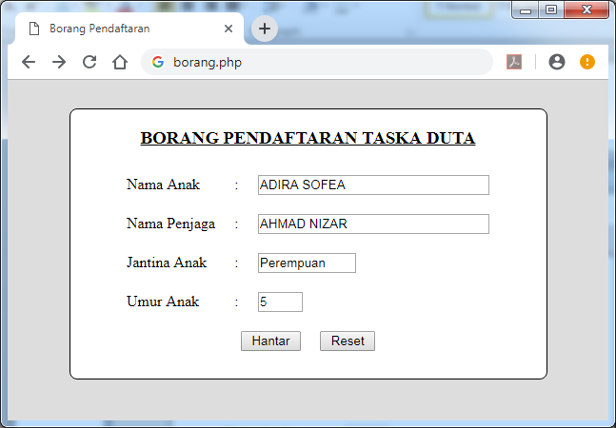

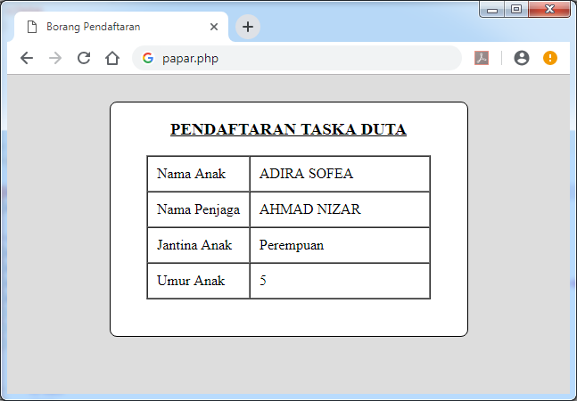

**<html>**

**<head>**

**<title> Borang Pendaftaran </title>**

**</head>**

**<body bgcolor="#ddd">**

**<center>**

**<div style="border-radius: 8px ; border: 1px solid black; width: 500px; margin-top: 30px; background-color: white;">**

**<form method="post" action="papar.php">**

**<h3><u>BORANG PENDAFTARAN TASKA DUTA</u><h3>**

**<table border=0 cellpadding=10 cellspacing=0>**

**<tr>**

**<td>Nama Anak</td>**

**<td>:</td>**

**<td><input type="text" name="anak" size="30"></td>**

**</tr>**

**<tr>**

**<td>Nama Penjaga</td>**

**<td>:</td>**

**<td><input type="text" name="penjaga" size="30"></td>**

**</tr>**

**<tr>**

**<td>Jantina Anak</td>**

**<td>:</td>**

**<td><input type="text" name="jantina" size="10"></td>**

**</tr>**

**<tr>**

**<td>Umur Anak</td>**

**<td>:</td>**

**<td><input type="text" name="umur" size="2"></td>**

**</tr>**

**<tr>**

**<td style="text-align: center;" colspan="3">**

**<input type="submit" name="hantar" value=" Hantar "> &nbsp&nbsp&nbsp**

**<input type="submit" name="reset" value=" Reset ">**

**</td>**

**</tr>**

**</table>**

**</form>**

**</div>**

**</center>**

**</body>**

**</html>**

**<?php**

**if(isset($_POST['hantar'])) {**

**//comment - declare variable**

**$anak = $_POST['anak'];**

**$jaga = $_POST['penjaga'];**

**$jantina = $_POST['jantina'];**

**$umur = $_POST['umur'];**

**}**

**?>**

**<html>**

**<head>**

**<title> Borang Pendaftaran </title>**

**</head>**

**<body bgcolor="#ddd">**

**<center>**

**<div style="border-radius: 8px ; border: 1px solid black; width: 400px; margin-top: 30px; background-color: white;">**

**<form method="post" action="papar.php">**

**<h3><u>PENDAFTARAN TASKA DUTA</u><h3>**

**<table border=1 cellpadding=10 cellspacing=0>**

**<tr>**

**<td>Nama Anak </td>**

**<td width="180px"> <?php echo $anak; ?></td>**

**</tr>**

**<tr>**

**<td>Nama Penjaga </td>**

**<td> <?php echo $jaga; ?></td>**

**</tr>**

**<tr>**

**<td>Jantina Anak </td>**

**<td> <?php echo $jantina; ?></td>**

**</tr>**

**<tr>**

**<td>Umur Anak </td>**

**<td> <?php echo $umur; ?></td>**

**</tr>**

**</table>**

**</form>**

**<br>**

**</div>**

**</center>**

**</body>**

**</html>**